Menus
This section details all of the menus in the program.

Application Menus
These menus are displayed when there isn’t an open project. This occurs when the program is first started or after project is closed.
Table 1 Application Menu
Menu Items | Submenu Items
File | New  Open  Print Setup  MRU  Exit
Help | Help Topics  Online Resources  About PGSuper

File
The File menu provides an interface for the operations that apply to a file.

New…
Displays the New Project dialog which lists the available project templates.
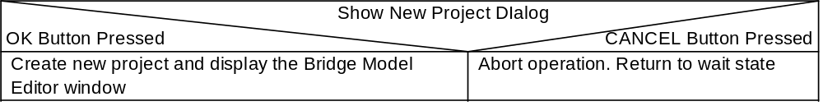

Open…
Opens an existing project workspace. At the completion of this operation all windows will be restored to their previous size and location.
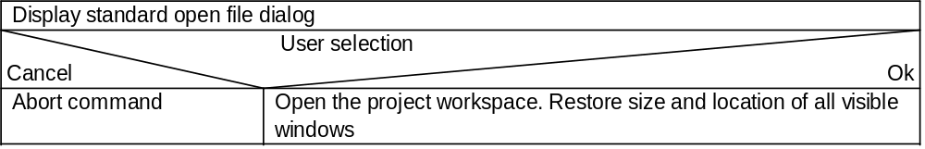

Print Setup
Used to select and configure a printer. Displays the standard print setup dialog.

MRU
List of the 4 most recently used projects. Selection of one of the most recently used projects will cause that project to be opened. The behavior is similar to that of File | Open.

Exit
Exits the program.

Help
The Help menu provides an interface for the operations pertaining to user assistance.

Help Topics
Provides access to the Help Topics Browser

Online Resources
This menu cascades to a submenu containing a “Visit WSDOT” option and “PGSuper Home Page” option. The first option opens the user’s default web browser and goes to the WSDOT home page. The second option opens the user’s default web browser and goes to the PGSuper Home Page where the most up to date information about PGSuper exists.

About PGSuper
Displays copyright and version information in the About Dialog.

PGSuper Project Menus
These menus provide an interface for manipulating the elements of a PGSuper project.
Table 2 PGSuper Project Menu
Menu Items | Submenu Items
File | New  Open...  Close  Save  Save As...  Export to Template File…  Properties...  Program Settings…  Print...  Print Setup...  Send  MRU  Exit
Project | Turn AutoCalc On|Off  Update Now  Design Girder...  Units...  Specification...  Environment...
Loads | Utilities...  Forms...  Load Modifiers…
Library | Edit Libraries  Add New Entry  Edit Entry  Delete Entry  Duplicate Entry  Large Icons  Small Icons  List
View | Bridge Model View  Girder View  Analysis Results  Reports...  View Settings  Toolbars...  Status Bar
Window | Cascade  Tile  Arrange Icons
Help | Help Topics  Tip of the Day…  Online Resources  About PGSuper...

File
The File menu provides an interface for the operations that apply to a file.

New…
Creates a new project. Before a new project can be created any open projects must be closed. See description of File | New for the Application Menu for additional information.
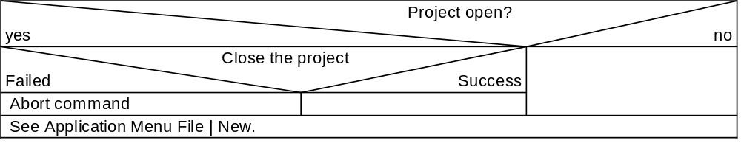

Open…
Opens an existing project workspace. The current project workspace must be closed before another workspace can be opened. At the completion of this operation all windows will be restored to their previous size and location.
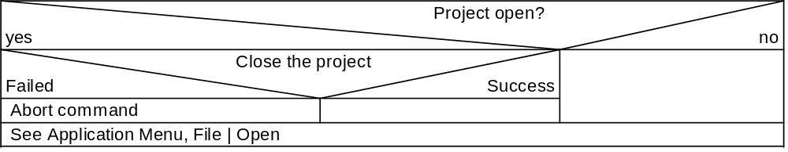

Close
Closes the project workspace. If the project has been modified a request to save the changes is made. If the project is unnamed, a request for a project name is made. At the completion of this operation the program will revert back to the program startup state.
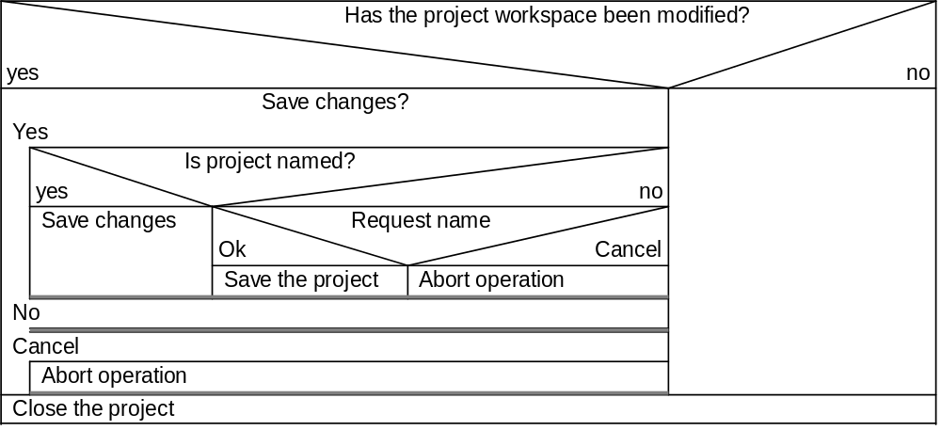

Save
Saves the current project workspace. If the project is unnamed, this operation becomes Save As. At the completion of this operation all modifications to the project since the last time it was saved are committed to disk. This operation is only available when a project workspace is modified.
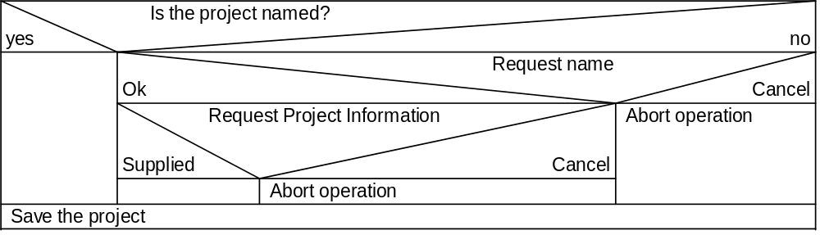

Save As
Saves the current project workspace with a name and location provided by the user. At the completion of this operation the project workspace is committed to disk with the name and location provided by the user.
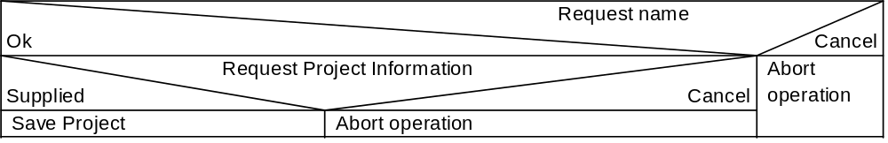

Export to Template File
Displays the standard Save As dialog. The users selects a file name and location to save the current project as a template for new projects.

Program Settings
Displays the Program Settings dialog.

Properties
Displays the properties of the project in the Project Properties Dialog.

Print
Print the contents of the current window. This operation is only available when a window with printable attributes is active (Plan View and Model Views are printable, the toolbars and the status bar are not printable).

Print Setup
Used to select and configure a printer. Displays the standard print setup dialog.

Send
Sends a mail message with the project as an attachment.

MRU
List of the 4 most recently used projects. Selection of one of the most recently used projects will cause that project to be opened. The behavior is similar to that of File | Open.

Exit
Exits the program. If the project has been modified, the user is given an opportunity to save the changes before the program exists.
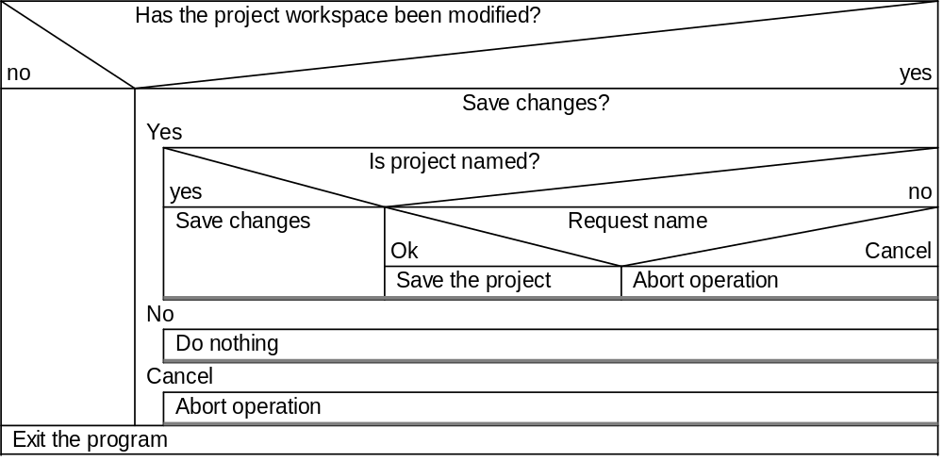

Project
The Project menu provides an interface for the settings and operations that pertain to the entire project. The Project menu is divided into three sections. The first section contains items that make the program do some work. The second section contains items that control how the work is to be done. The third section contains items that control the settings of global factors.

Turn AutoCalc On/Off
Toggles AutoCalc Model on and off. When AutoCalc mode is on, the menu text is Turn AutoCalc Off.

Update Now
Causes the program to update all views. This option is only available if AutoCalc is off and there are pending view updates.

Design Girder...
Displays the Girder Design Dialog where a girder is selected for design. After the user selects the girder for design, a progress window is displayed that shows the programs progress. After the completion of the design, the Design Outcome Dialog is displayed.

Units...
Displays the System of Units dialog. This dialog is used to set the active system of units for the program.

Specification...
Displays the Specification dialog. This dialog is used to set the active specification for the program.

Environment...
Displays the Environment dialog. This dialog is used to set environmental conditions for this bridge project.

Loads
The Loads menu provides an interface for the operations that manipulate loads applied to the analysis models. The menu is divided into two sections. The first section provides operations that manipulate externally applied, user defined loads. The second section provides operations that manipulate generated loads. Only the second section is implement in this version of PGSuper.

Forms...
Displays the Form Work Load Dialog. This dialog is used to set the magnitude of the form work load.

Utilities...
Displays the Utility Load Dialog. This dialog is used to enable or disable the application of utility loads to the Bridge Site, Stage 2 model.

Load Modifiers…
Displays the Load Modifiers Dialog. This dialog is used to edit the LRFD load modifiers (the η factors).

Library
The Library menu provides an interface for the operations that pertain to managing library entries.

Edit Libraries
Opens the Library Editor Window.

Add New Entry
Creates a new library entry.

Edit Entry
This is a generic command that displays the editing dialog for the currently selected library entry.

Delete Entry
Deletes the selected library entry

Duplicate Entry
Duplicates the selected library entry

<Display Mode>
This menu item is actually three items that are part of a radio button group. The three items are Large Icons, Small Icons, and List. The list view pane of the Library Editor changes into the various display modes as each menu item is selected.

View
The View menu provides an interface for the operations that display and hide elements of the user interface, access the various views the program offers, and that control how information is presented in the views.

Bridge Model View
Displays the Bridge Model View.

Girder View
Displays the Girder View,

Analysis Results
Displays the Analysis Results View.

Report...
Displays the Report Selection Dialog, followed by the selected report.

View Settings
This menu item cascades to menu items for the Bridge Model View, and Girder View. Each command displays the view settings dialog for the corresponding view.

Toolbars...
Displays the Toolbar Dialog. This dialog is used to display or hide toolbars.

Status Bar
Displays or hides the status bar.

Window
The Window menu provides an interface for the operations that manipulate the size and location of child windows.

Cascade
Rearranges all display windows into a cascade pattern. The toolbars, and status bars are not effected by this operation.

Tile
Tiles all open windows. The toolbars, and status bars are not effected by this operation.

Arrange Icons
Arranges all minimized window icons.

Help
The Help menu provides an interface for the operations pertaining to user assistance.

Help Topics
Provides access to the Help Topics Browser.

Tip of the Day…
Displays the tip of the day dialog

Online Resources
Provides access to online resources. See Section for details.

About the program
Displays copyright and version information.

